**AWS CloudWatch Alarm for CPU Utilization**

**Steps:**

1. **Launch an EC2 instance in the name of “WebServer”.**

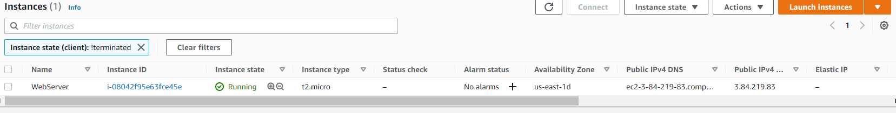

1. **Default monitoring will be done for the instance and all the services.**

**It is free of cost.**

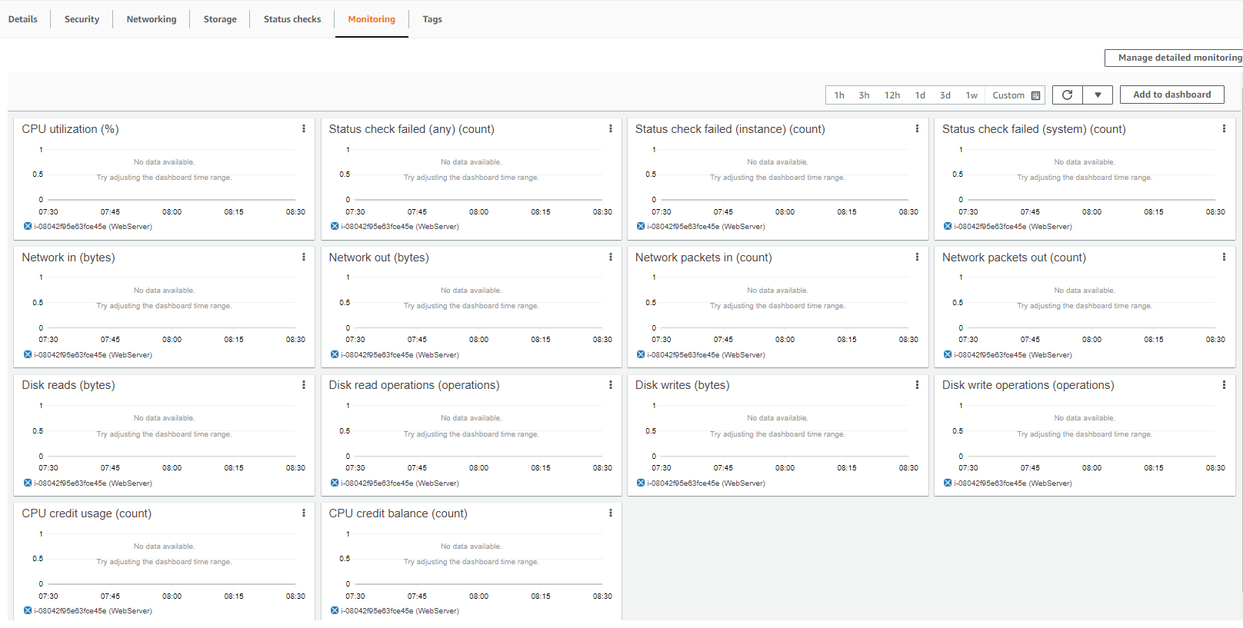

1. **Open CloudWatch**

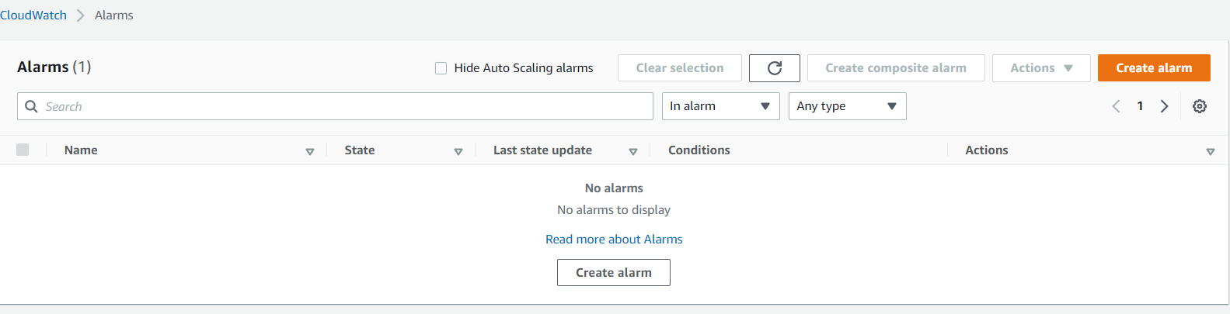

**Click on create alarm.**

1. **We need to specify metrics and conditions.**

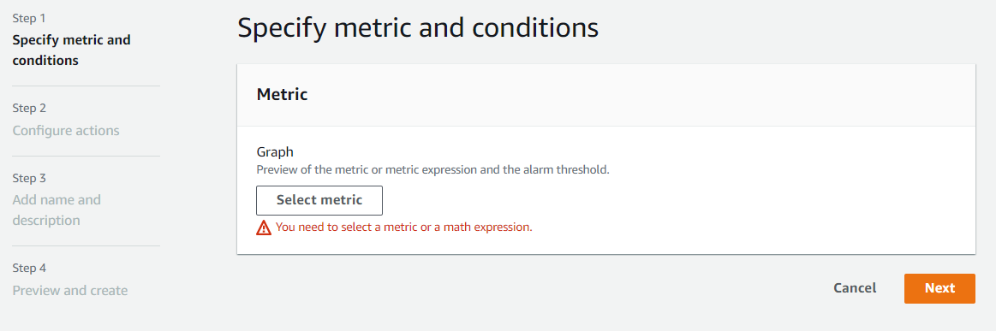

**Click “select metric”**

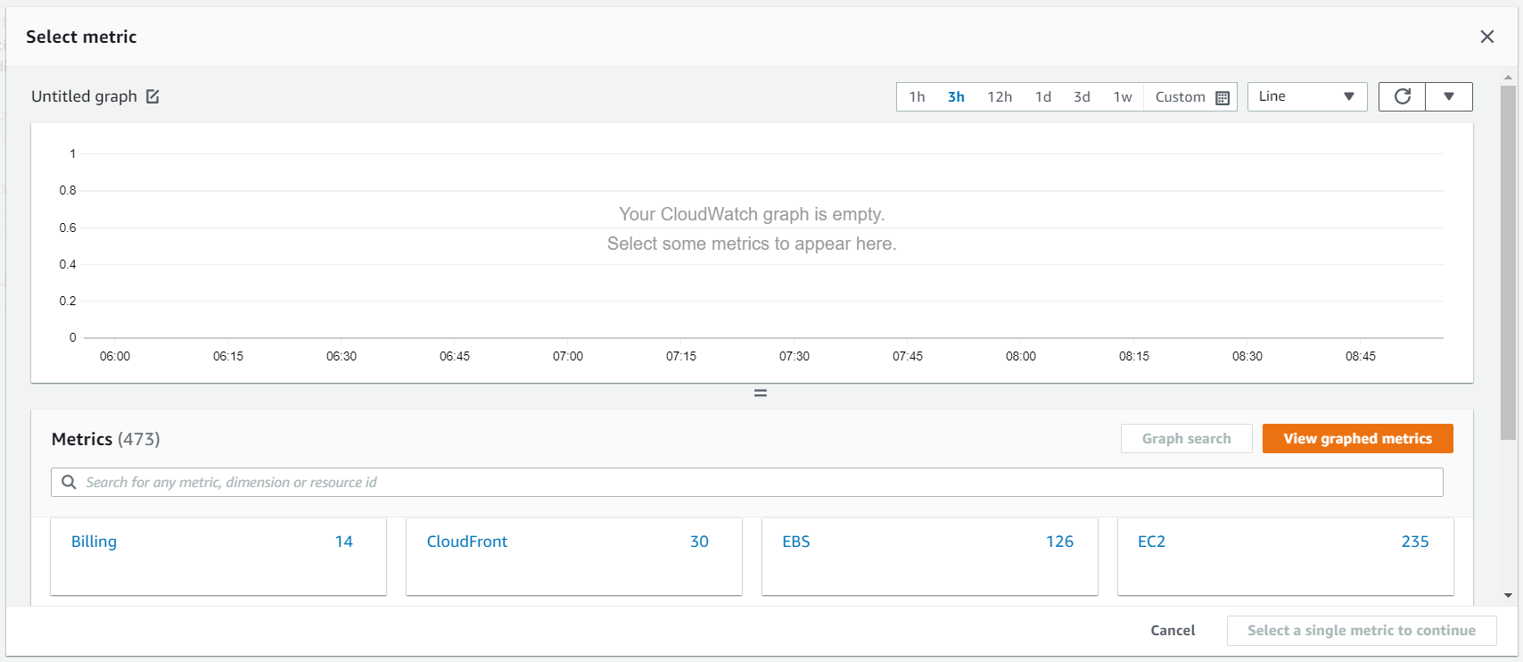

**Click on “EC2”**

**And click on “Pre-Instance Metrics”**

**Select “CPU Utilization”**

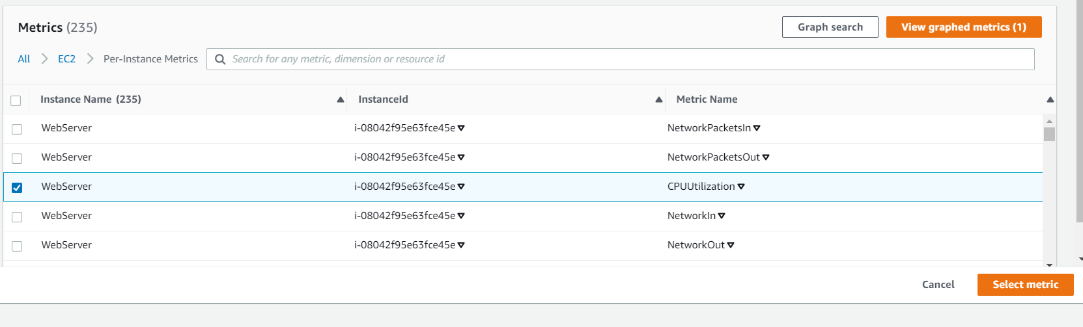

**Click on select metrics.**

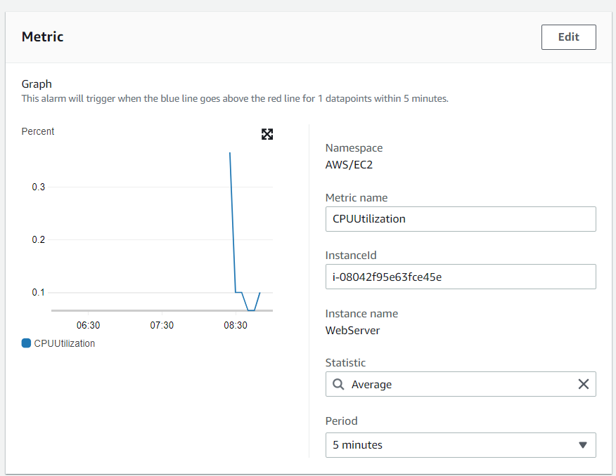

**Here we are defining the threshold value as 70.**

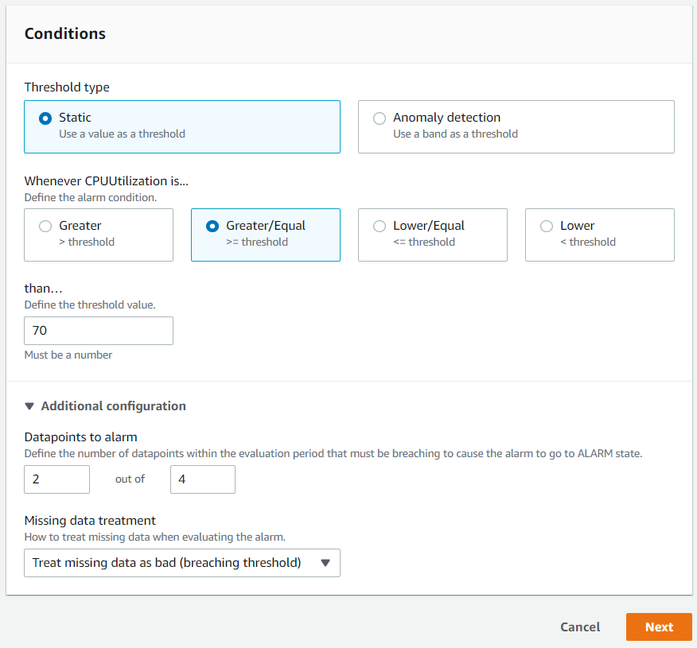

**Click on “Next”.**

1. **Configure Actions:**

**Create a topic**

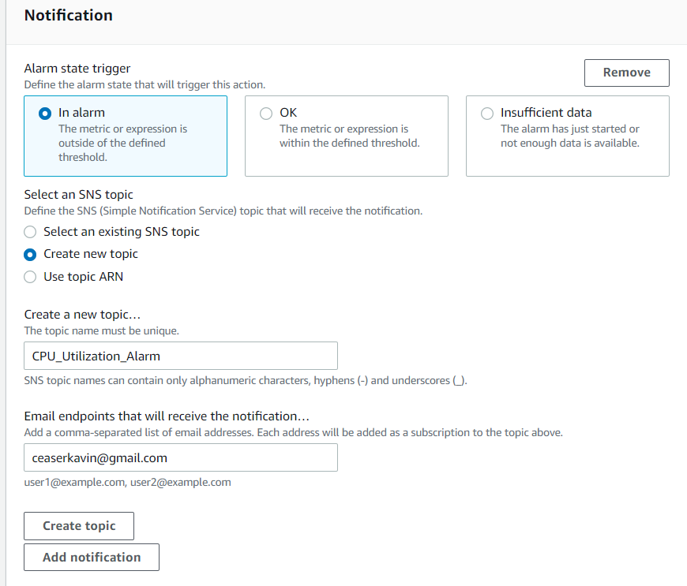

**Accept the Email subscription request.**

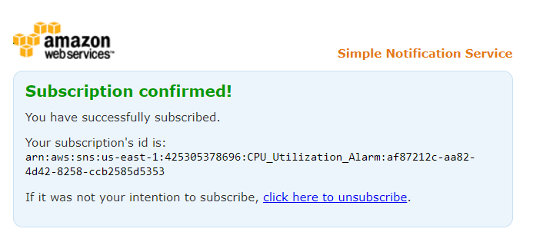

**If we need, we can choose auto scaling**

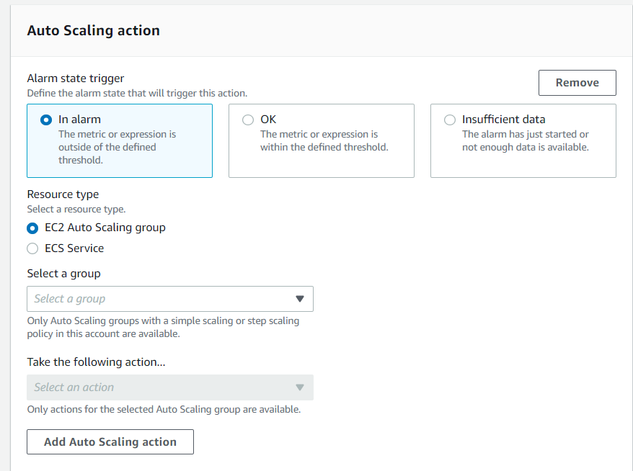

**We can fix the following actions on the EC2 instance when the utilization reaches the fixed range.**

**Here we are giving stop the instance as the action.**

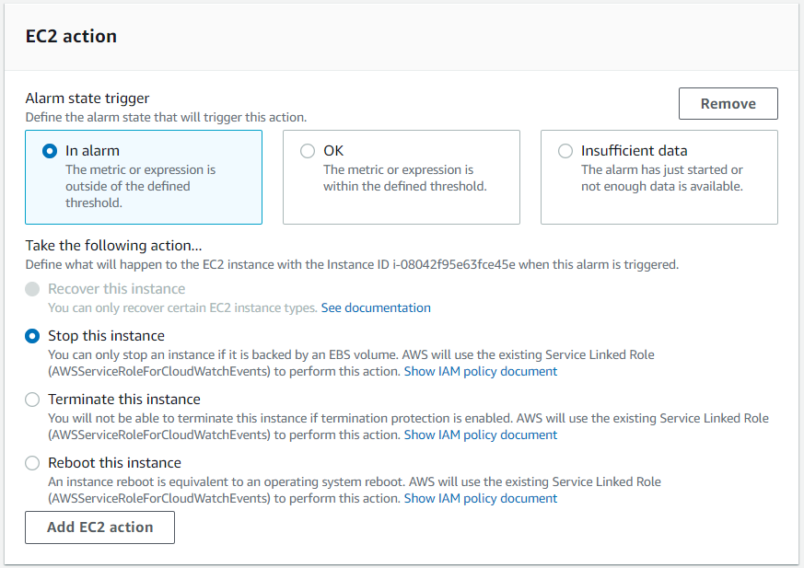

**Click next.**

1. **Name the alarm and click next.**

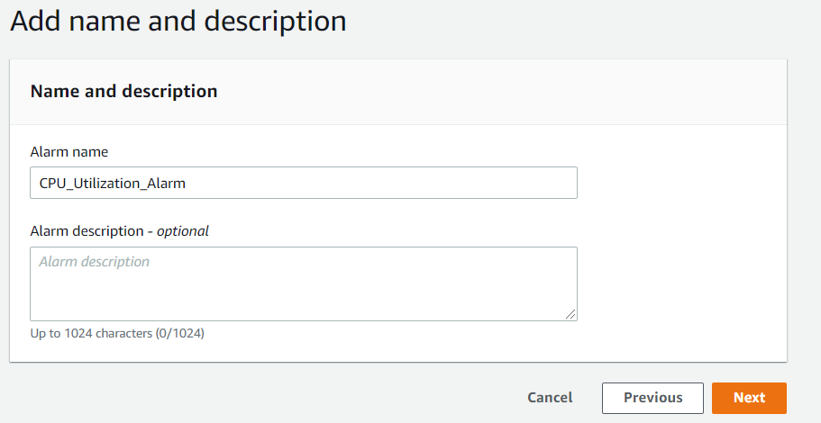

1. **Click create alarm.**

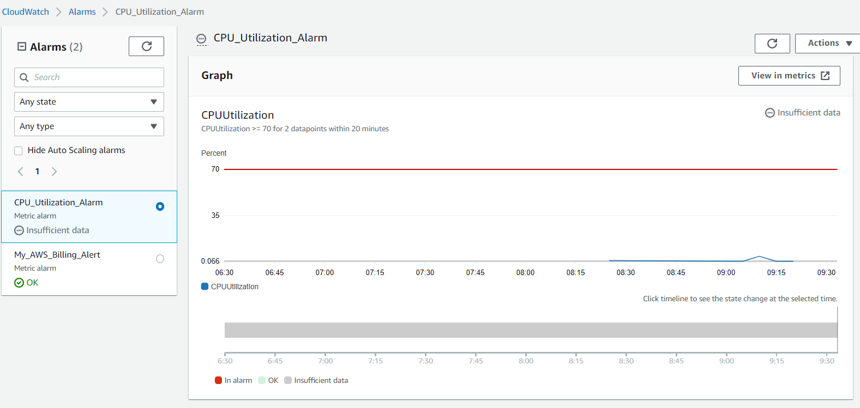

**Alarm has been created successfully.**

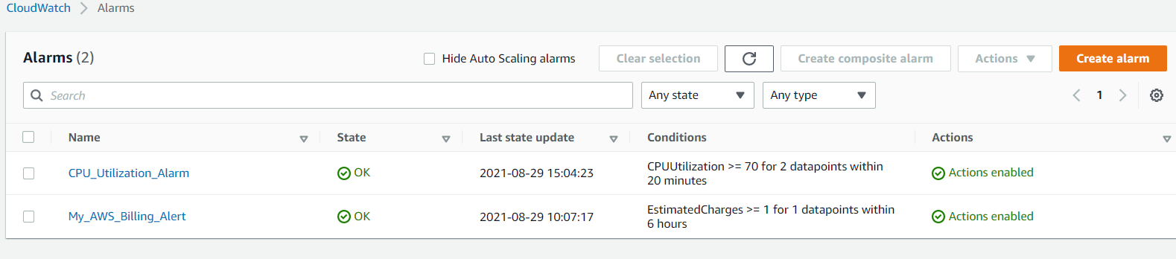

**To Check the working of alarm Connect the EC2 instance and introduce stress to increase the load of the CPU.**

**Stress Commands:**

You need to install stress first then after that, you can test the CPU usage. Then you need to run the commands for stress.

​**commands to install stress:** sudo yum install -y stress

**to check the current CPU utilization use:** uptime

you will get the usage then increase the workers(nothing but the number of nodes) by using this command.

sudo stress --cpu  8 --timeout 20

here we are using 8 workers to increase the stress, now run the uptime command again and check the stats if it doesn't reach required usage then increase the number of workers. Thus, you can use the stress command and test auto-scaling.

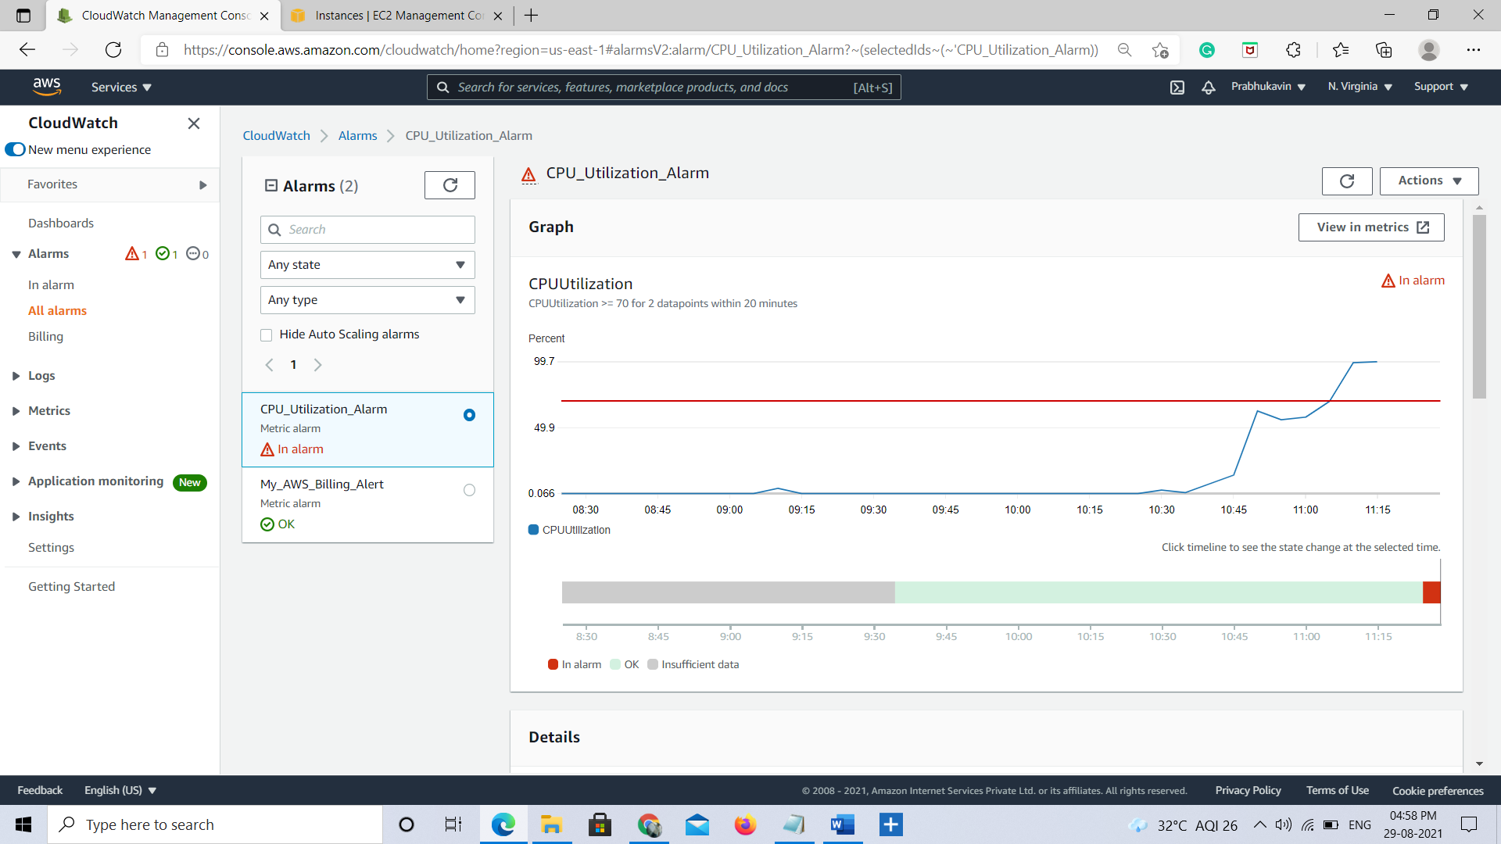

**We will receive a mail like this**

